HA1

Linear Equations Test REVIEW

Topics:

* Slope and Rate of Change
* 3 Forms
  + Slope-Intercept
  + Standard Form
  + Point-Slope Form
* Arithmetic Sequences
* Scatter Plots and Regression
  + By hand
  + With Calculator
* Linear Inequalities
* Linear Inverse
* Direct Variation
* Parallel and Perpendicular Lines
* Graphs

Practice:

What is the slope of the line that passes through (4, -6) and (10, 2)?

What is the equation for the **inverse** of the function y = 4x - 5 ?

Given the line 2x + 3y = 4, what is the y-intercept?

Write an equation of a line in slope-intercept form that passes through the points

(-6, 6) and (9, 1). Convert to Standard Form.

Determine the equation of a line that is parallel to the line y = 3x – 5, and passes

through the origin.

Determine the equation of the line in standard form that is perpendicular to the line

y = 3x - 5 and passes through the point (-6, 1).

Write an equation of a line in point-slope form that passes through the point (2, 6)

and has a slope of –3. Convert to Slope-intercept.

Write an equation of a line in slope-intercept form that passes through the

point (-1, -3) and has slope m = .

Given the function, . Determine .Then graph f(x), , and the line y = x on the coordinate axes below.

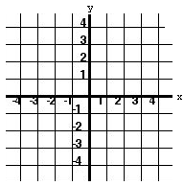

Determine the inverse of {(-2, -2), (2, -2), (4, 2)}

Assume that y varies directly with x. When x = 25, y = 42.

Determine y when x = 35.

Find r for which the points (r, 27) and (5, 6) have a slope of .

List the following r-values from weakest to strongest:

1. 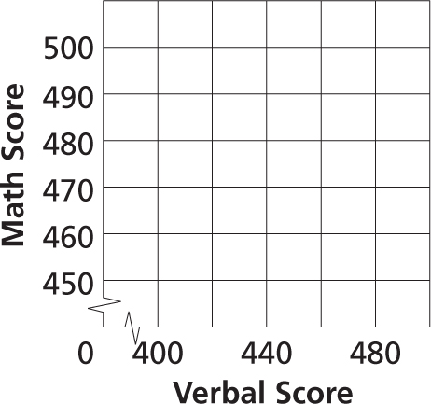Make a scatter plot relating the verbal scores and the math scores.

|  |  |  |
| --- | --- | --- |
| **State Graduation Scores** | | |
| **Year** | **Verbal Score** | **Math Score** |
| 1975 | 460 | 488 |
| 1985 | 424 | 466 |
| 1995 | 410 | 463 |
| 2005 | 420 | 460 |

Does the scatter plot show a *positive*, a *negative*, or *no correlation*? What does that relationship represent?

Write the equation for a line of fit. Predict the corresponding math score for a verbal score of 445.

1. The table gives the life expectancy of a child born in the United States in a given year.
2. Enter the data into the calculator. Use years since 1920 as the independent variable

|  |  |
| --- | --- |
| **Years of Life Expected at Birth** | |
| **Year of**  **Birth** | **Life Expectancy**  **(years)** |
| 1920 | 54.1 |
| 1930 | 59.7 |
| 1940 | 62.9 |
| 1950 | 68.2 |
| 1960 | 69.7 |
| 1970 | 70.8 |
| 1980 | 73.7 |
| 1985 | 74.7 |
| 1990 | 75.4 |
| 1995 | 75.8 |

1. Describe the correlation of the scatterplot.
2. Find the linear regression Equation
3. What is the r-value? What does the r-value indicate?
4. Use the data to predict the life expectancy of a baby born in 2016. Explain how you determined your answer (interpolation or extrapolation). Is your answer reasonable in context?

Graph the following Inequalities

|  |  |
| --- | --- |
| Write one solution: |  |
| Write one solution: |  |

Find the missing terms: _____, 71, ______, ______, -22 , _____ ….

Write a formula for this sequence:

What is the 13th term?